Accessing Citrix

- Open Internet Explorer and go to: https://shp.dhh.la.gov

- The Citrix Access Gateway login screen appears. Enter your Citrix user name and password. If you previously used the SHP VPN to access CAREWare, these are your same credentials.
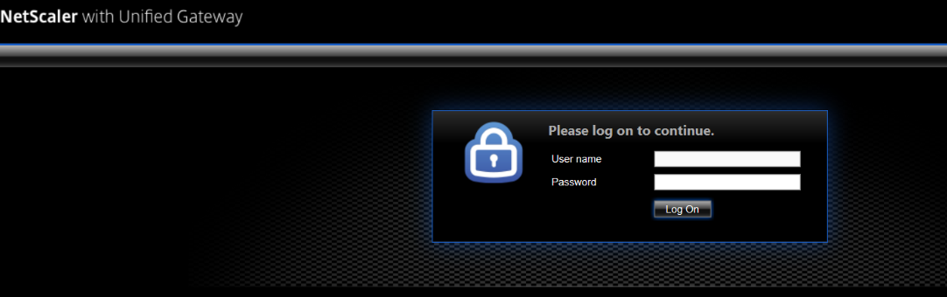

- If you haven’t access Citrix previously, you will need to install the Citrix Receiver application.
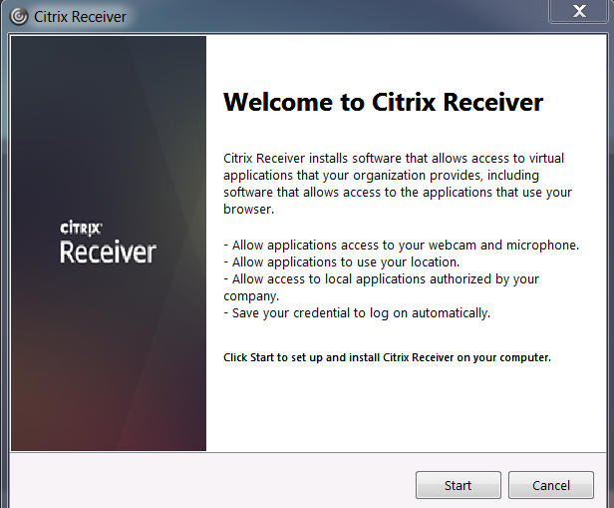

- Check the box to agree to the user terms and then click Install.
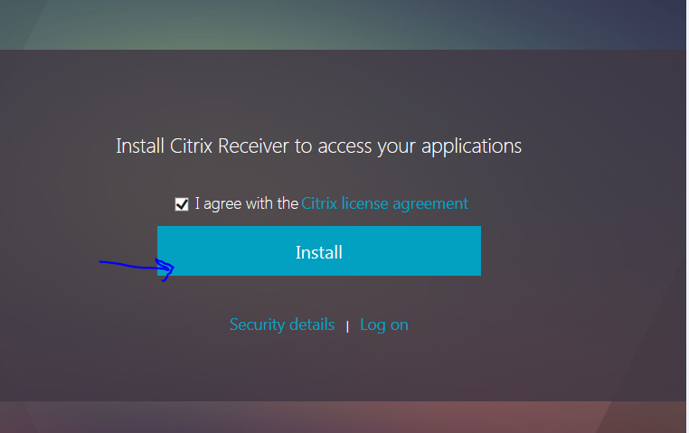

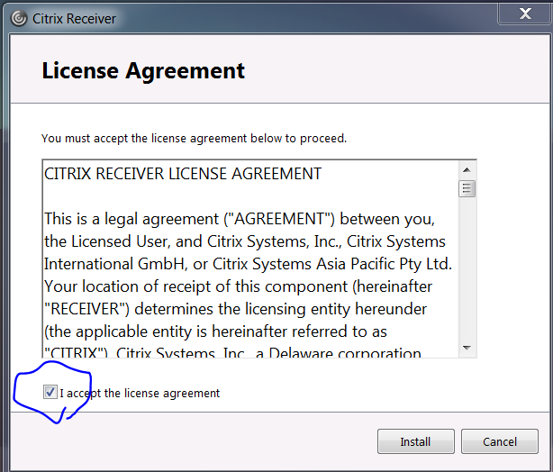

- When the application setup box appears, click RUN.
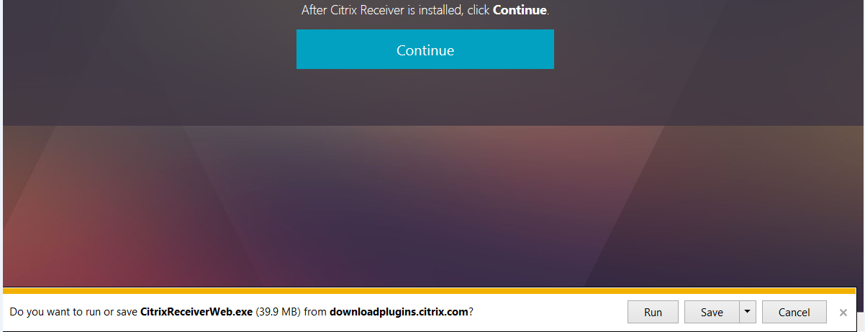

- Click RUN again when asked if you want to run the software.

- Click ALLOW on the ActiveX control box.
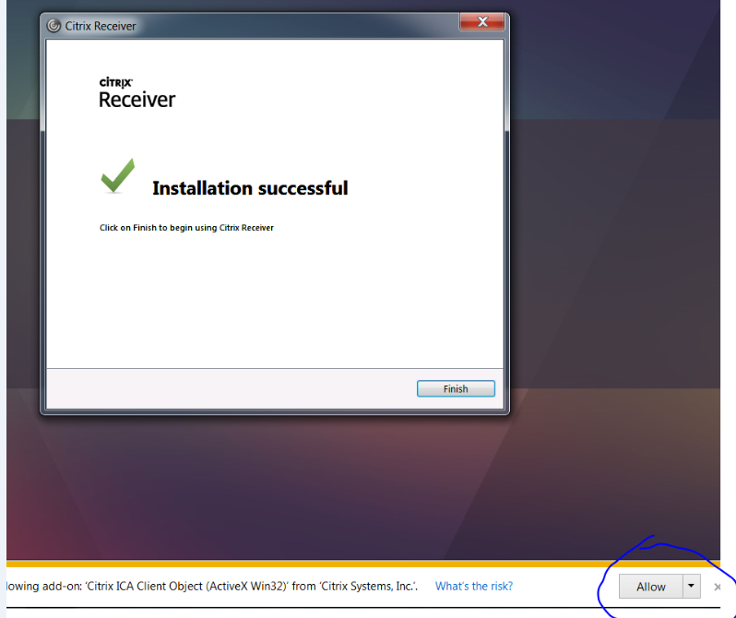

- You’ll then be given a message that your installation was successful. Click Finish.

- Once installation is successful, every time you log in you will be brought to a screen that has an icon for the CAREWare Desktop. Click this icon ONCE to launch the desktop.

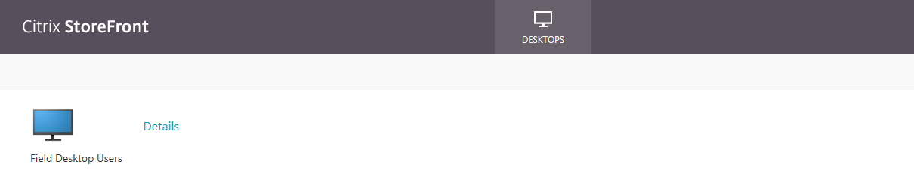

- You will have a new window pop up. If you get a security warning (shown below), click Permit Use.

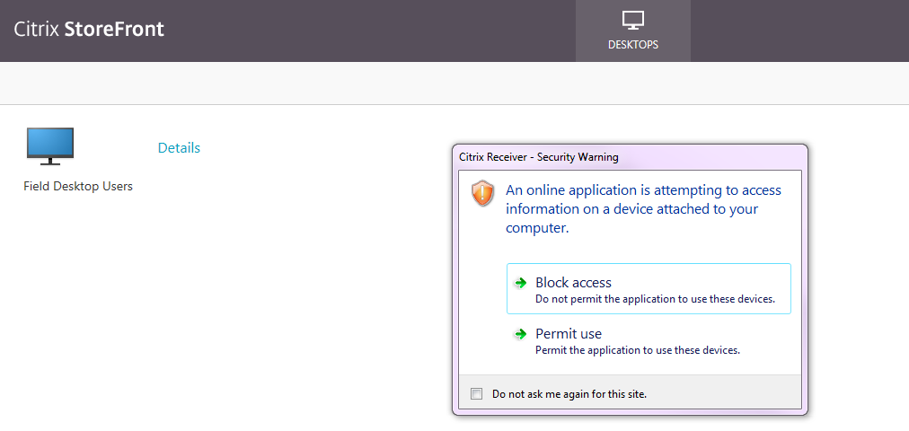

- If the message below appears, check the box and close the window. You do not need to put anything in the address bar.

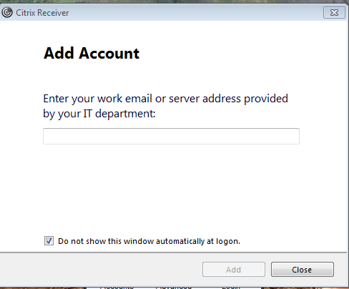

- Click on the file folder button located on the bottom left corner of the desktop

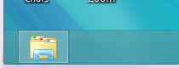
- Select the “M Drive”
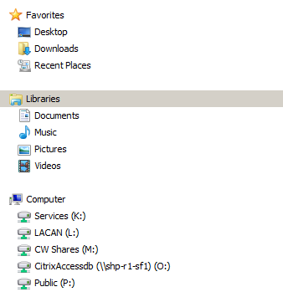

- Select the “Users” folder
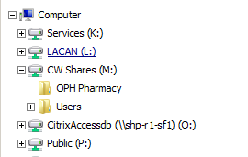

- Select your agency folder

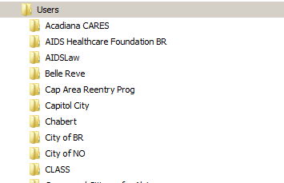

- Select the folder with your name on it.
- Click on the file you wish to open

Moving files from your computer to your shared folder:

- Be sure to save the file to a network drive. Make sure it is one that you will remember.
- For example: If you were saving a word document you would click the “Save” button at the top of the document
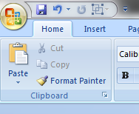

- Select a network to save to. (These are just an example of some Network drives. The ones on your computer will be different.) In this example we will use the “K” drive.
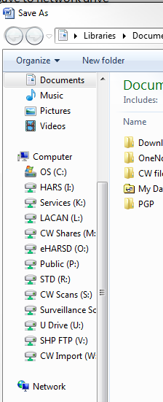
**Note**
If you save a file to your computer “Desktop” or your computer “Documents” it will NOT show up on Citrix’s “Desktop” or “Documents”. The opposite is also true. If you save something to Citrix’s “Desktop” or “Documents” it will NOT show up on your computer’s “Desktop” or “Documents”.

- Once you have selected a network drive find the file you want to save to, Select the location you want to save to in the network. (You may have a reports folder or a folder with your name on it. It doesn’t matter as long as you can remember where you saved your document.)
- Go to the Citrix Desktop. (See steps 1-4 of the “Accessing your shared folder” instructions)
- Select the drive where you saved the document.( For this example we used the “K” drive)

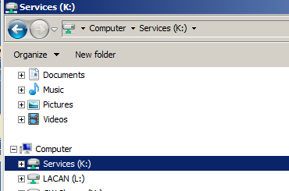

4. Find the location in that network drive where you saved the document.
5. Right click on the file and select “Copy
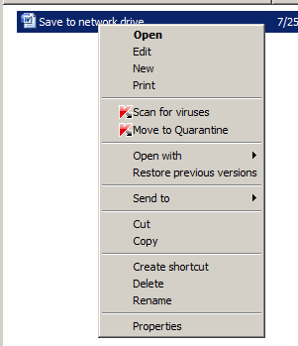
6. Click on the M Drive
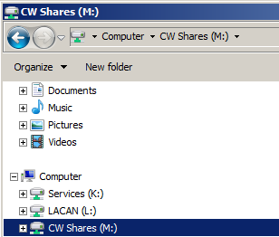

7. Select “Users”
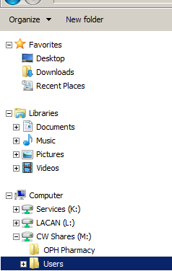

8. Click on your agency’s folder
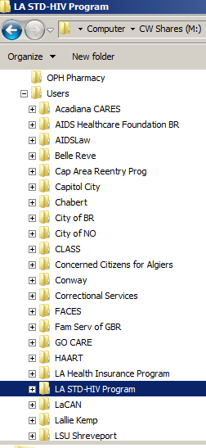

9. Click on your folder
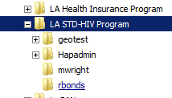
10. Right click again and select “Paste” to put the file in your shared folder.

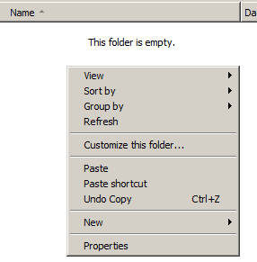

11. Your file will now be in your shared folder.

